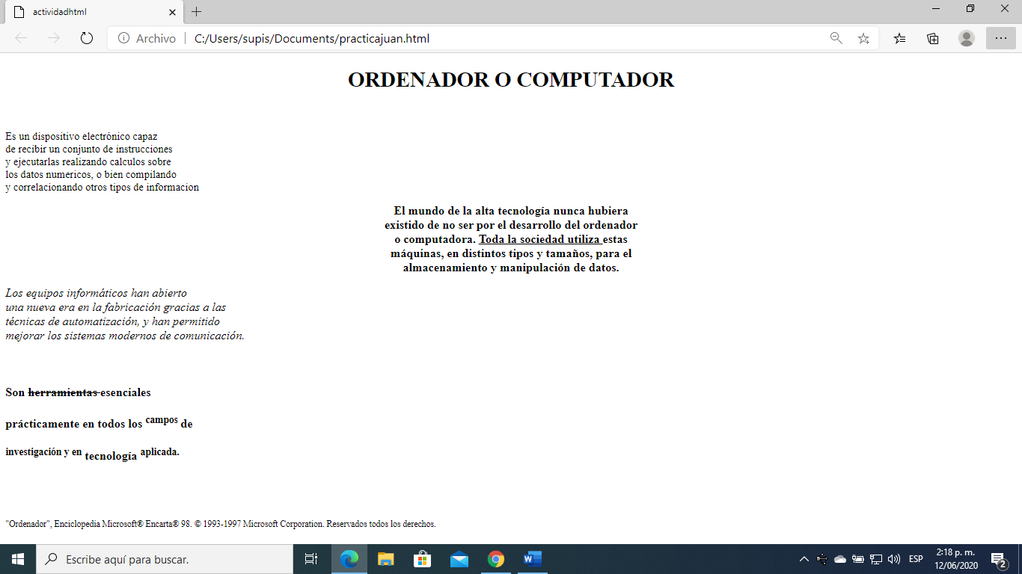[file:///C:/Users/supis/Documents/practicajuan.html](file:///C:\Users\supis\Documents\practicajuan.html)